Project Report Form
Please complete and email to mvartcouncil@gmail.com within 60 days of project completion (unless extension approved by Board of Directors).

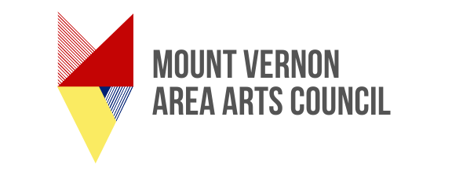

- How were the MVAAC funds spent?

- Were all the MVAAC funds spent?

- What impact did the grant have in the community and/or the population served?

- Please include photographs and printed materials if applicable.

